Thursday 23rd January 2024

Dear Parents/Carers,

**Year 5 School Residential to PGL Windmill Hill (Sussex)**

**Monday 28th April – Wednesday 30th April 2025**

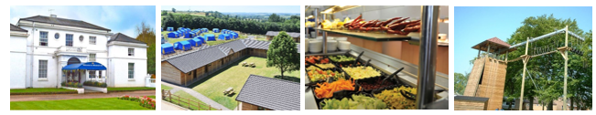

We are excited to announce this year’s residential to PGL Windmill Hill (Sussex) trip will run from Monday, 28th to Wednesday, 30th April.

The cost of the trip will be £200, this is heavily subsidised by the school. Families receiving free schools meals are entitled to a further discount and will pay only £150.

If you would like your child to attend school journey to Windmill Hill in April 2025 you will need to make your first payment to the school office by Friday 31st January. A payment plan is in place to support families in spreading the cost over a period of two months. All payments will need to be made via Scopay.

**Spaces for school journey go fast, and are allocated on a first come first serve basis.**

**Payment Plan**

|  |  |  |
| --- | --- | --- |
| **Week beginning** | **£200** | **£150 (Free Schools Meals)** |
| 31st January | £25 | £18 |
| 7th February | £25 | £18 |
| 14th February | £25 | £18 |
| 21st February | £25 | £18 |
| 28th January | £25 | £18 |
| 7th March | £25 | £20 |
| 14th March | £25 | £20 |
| 21st March | £25 | £20 |

If you have any questions or queries regarding school journey please do not hesitate in speaking to me.

Yours sincerely,

Ms Nelson

Deputy Headteacher (Upper School)

---------------------------------------------------------------------------------------------------------------------------------------

**Year 5 School Residential to PGL Windmill Hill (Sussex)**

I would like my child ___________________________________in ____________________ class to attend the school residential between Monday **28th April – Wednesday 30th April 2025.**